Module 3: Financial Analysis
Financial Analysis helps organizations understand their financial health, profitability, liquidity, and future performance. Excel is one of the most widely used tools for financial analysis and decision-making.

3.1 Financial Basics
A. Financial Statements
1. Profit & Loss Statement (P&L)
Shows company profit over a period.
Particulars | Amount (₹)
Sales Revenue | 500,000
Cost of Goods Sold | 300,000
Gross Profit | 200,000
Operating Expenses | 80,000
Net Profit | 120,000
Formula
Net Profit = Revenue − Expenses

2. Balance Sheet
Shows assets and liabilities.
Assets | Amount (₹)
Cash | 50,000
Inventory | 100,000
Equipment | 150,000
Total Assets | 300,000

Liabilities | Amount (₹)
Loan | 120,000
Owner Equity | 180,000
Total | 300,000
Formula
Assets = Liabilities + Equity

3. Cash Flow Statement
Tracks movement of cash.
Activity | Cash Inflow | Cash Outflow
Sales Collection | 100,000
Salary Payment |  | 30,000
Rent Payment |  | 10,000
Net Cash Flow | 100,000 | 40,000

Financial Statements Diagram
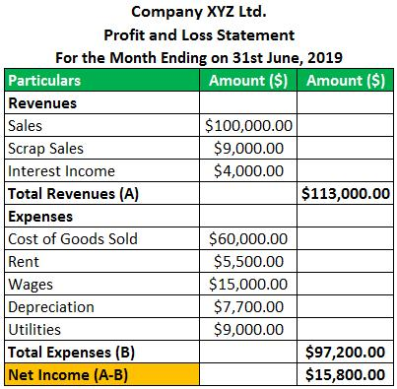
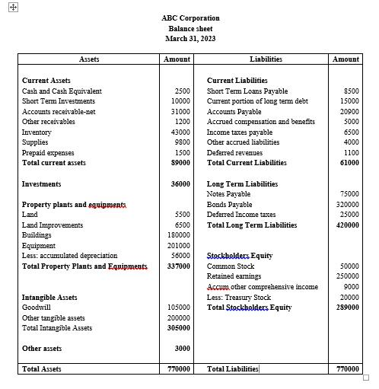
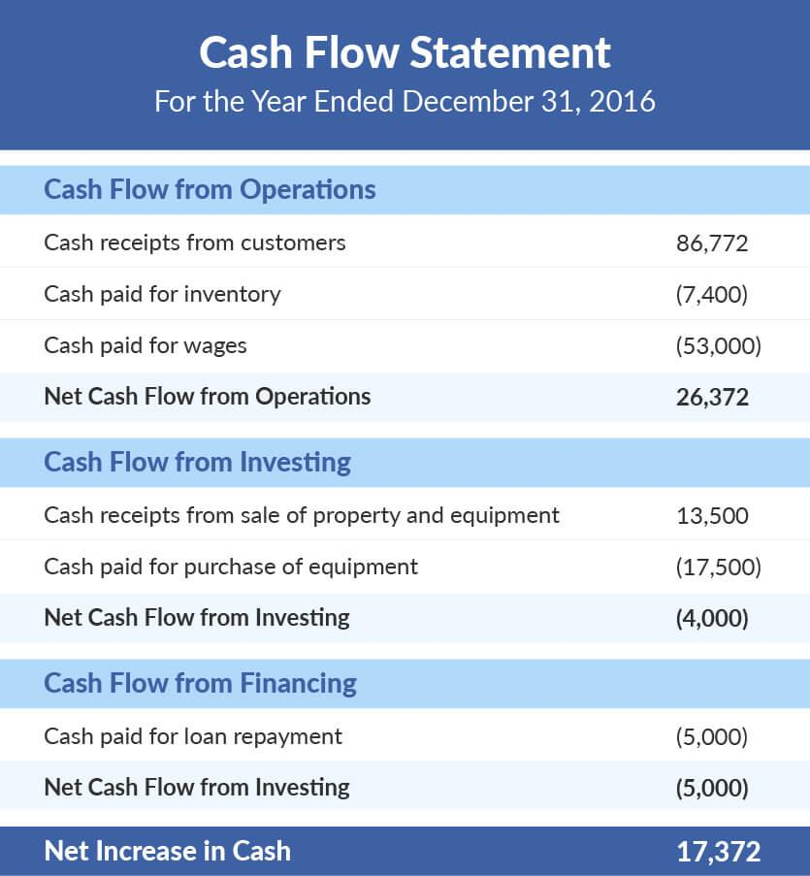

B. Key Financial Terms
Term | Meaning
Revenue | Total income from sales
Expense | Cost incurred
Profit | Revenue − Expenses
Asset | Owned resources
Liability | Debt or obligations
Equity | Owner's share
Cash Flow | Cash movement

3.2 Ratio Analysis
Ratios help evaluate business performance.

A. Profitability Ratios
Gross Profit Margin
Formula:
Gross Profit Margin =
Gross Profit / Revenue × 100
Excel:
=(B2-C2)/B2*100
Example:
Revenue = ₹500,000
COGS = ₹300,000 (COSC- Cost of Goods Sold.)
Result:
40%

Net Profit Margin
Formula:
Net Profit / Revenue × 100
Excel:
=E2/B2*100

B. Liquidity Ratios
Current Ratio
Measures ability to pay short-term liabilities.
Formula:
Current Assets / Current Liabilities
Example:
Assets = ₹200,000
Liabilities = ₹100,000
Current Ratio = 2
Excel:
=B2/C2

Quick Ratio
Formula:
(Current Assets − Inventory)
/ Current Liabilities

C. Efficiency Ratios
Inventory Turnover
Formula:
COGS / Average Inventory
Higher value indicates efficient inventory management.

Asset Turnover Ratio
Formula:
Revenue / Total Assets
Measures asset utilization efficiency.

Ratio Analysis Illustration
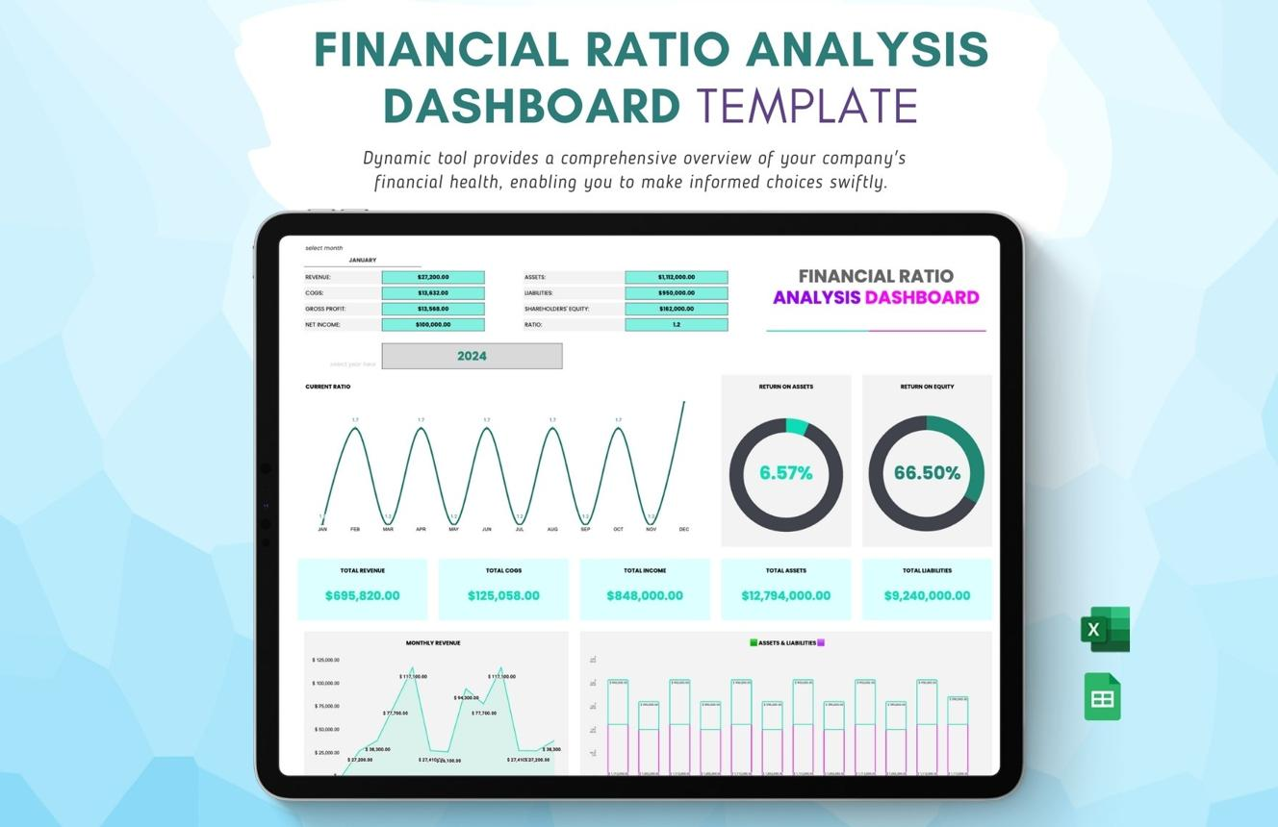
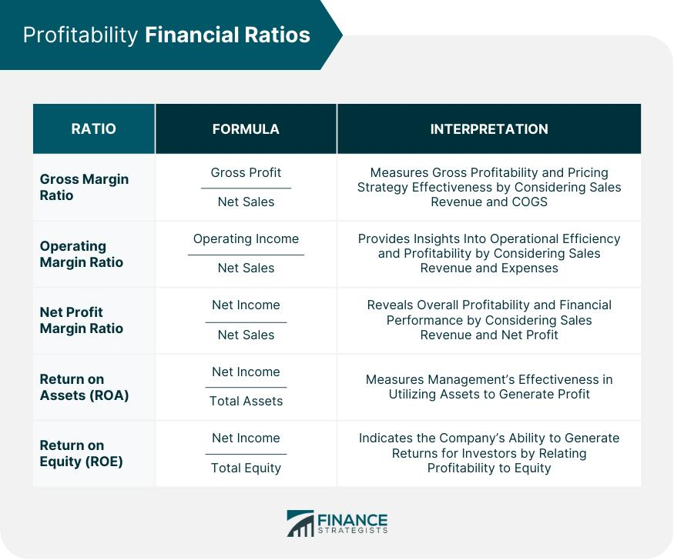
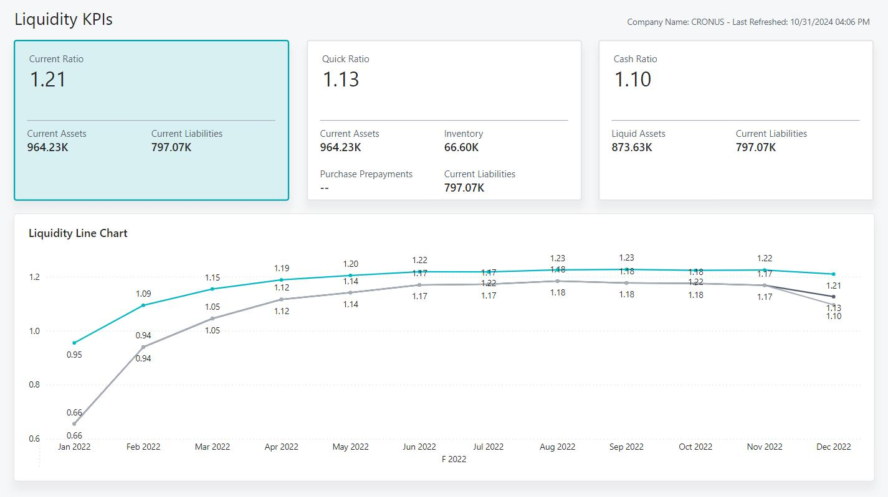

3.3 Excel for Financial Analysis

A. Forecasting Techniques
Used to predict future sales or revenue.
Dataset
Month | Sales
Jan | 10000
Feb | 12000
Mar | 13000
Apr | 15000
May | 17000

Method 1: FORECAST Function
Future Sales for June:
=FORECAST(6,B2:B6,A2:A6)
Result:
Approximately ₹18,200

Steps
- Enter historical sales.
- Select future period.
- Use FORECAST function.
- Analyze predicted values.

B. Budgeting Models
Example Budget
Expense | Budget
Salary | 50,000
Rent | 20,000
Marketing | 15,000
Utilities | 5,000
Total | 90,000
Steps
- Create expense categories.
- Enter planned budget.
- Enter actual spending.
- Calculate variance.
Formula:
=Actual-Budget

C. Break-Even Analysis
Determines when profit becomes zero.
Data
Item | Value
Fixed Cost | ₹100,000
Selling Price | ₹100
Variable Cost | ₹60

Formula
Break-Even Units =
Fixed Cost /
(Selling Price − Variable Cost)
Calculation:
100,000 / (100−60)
= 2,500 Units

Excel Formula
=B2/(B3-B4)

Steps
- Enter fixed cost.
- Enter selling price.
- Enter variable cost.
- Apply formula.
- Determine required sales units.

Break-Even Chart
The Break-Even Point (BEP) is the point where:
Total Revenue = Total Cost
At this point:
✅ No Profit
✅ No Loss
This means the business has recovered all its costs.
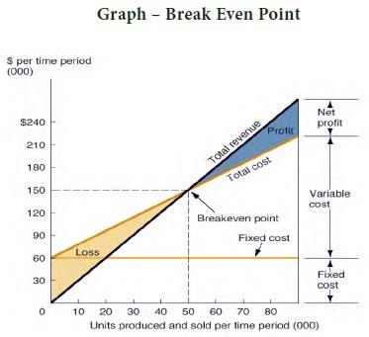
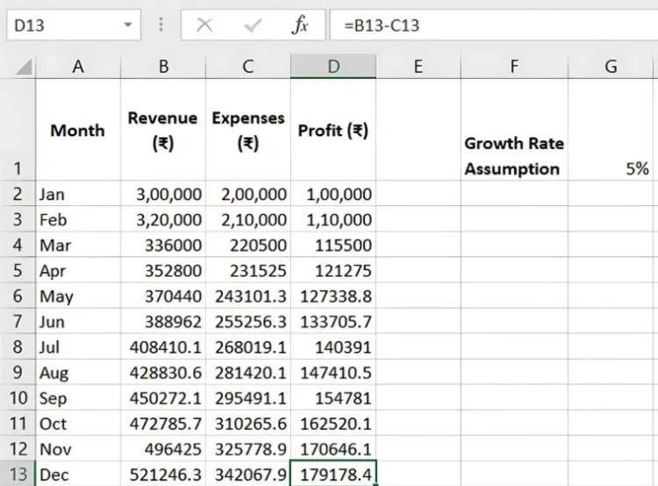
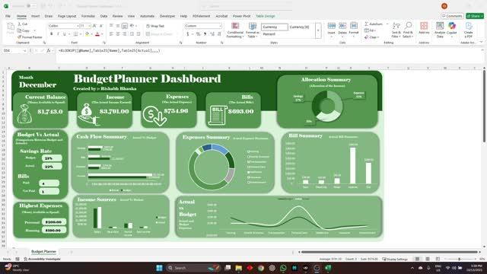

3.4 Case Study: Real-World Financial Dataset Analysis
Dataset
Product | Revenue | Cost
Product A | 120000 | 80000
Product B | 90000 | 50000
Product C | 150000 | 100000

Step 1: Calculate Profit
Formula:
=B2-C2
Product | Profit
A | 40,000
B | 40,000
C | 50,000

Step 2: Calculate Profit Margin
Formula:
=(Profit/Revenue)*100

Step 3: Create Pivot Table
- Select data.
- Insert → Pivot Table.
- Drag Product to Rows.
- Drag Revenue and Profit to Values.

Step 4: Create Dashboard
Add:
- Revenue KPI
- Profit KPI
- Profit Margin %
- Product-wise Chart
- Trend Analysis

Decision-Making Insights
Findings
✔ Product C generates highest profit.
✔ Product A has good sales but higher costs.
✔ Product B has better cost efficiency.
Business Decisions
- Increase investment in Product C.
- Reduce costs for Product A.
- Expand Product B marketing.

Interview Questions
Q1. What are the three major financial statements?
Answer: P&L Statement, Balance Sheet, and Cash Flow Statement.
Q2. What is Current Ratio?
Answer: Current Assets divided by Current Liabilities.
Q3. What is Break-Even Point?
Answer: The sales level where total revenue equals total cost.
Q4. Which Excel function is used for forecasting?
Answer: FORECAST() or FORECAST.LINEAR().
Q5. Why is ratio analysis important?
Answer: It helps evaluate profitability, liquidity, and operational efficiency of a business.

